**Use case diagram**

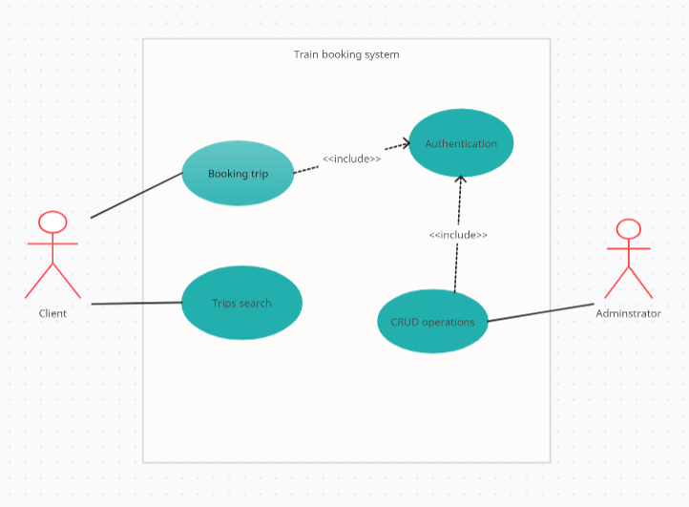

**Use case Scenario**

|  |  |
| --- | --- |
| Use case name | Authentication |
| Description | Client when treat with the system he must be authenticated first to be able to perform some functionalities like booking a ticket from the system. |
| Actors | Client, Administrator |
| Pre-conditions | -------------------------------------------------- |
| Post-conditions | *“You have successfully registered”* massage to the user |
| Main flow | 1-Client provide personal information like (first name, last name, phone number, sex)  2- Client enter an email and password.  3-System check if the provided personal information in valid format.  4-System check if the email in valid format.  5-System check if the email is not already exist.  6-system check if the password is satisfying system password rules.  7-system sends conformation email to the user to check if the email is actually Client’s own.  8-system insert provided information to the system database.  9-system forward the user to login directly. |
| Alternative flow | 3a personal information is not in valid format   1. system refuses the provided information and ask the user to enter it again. 2. Use case resumes at main flow step 1   4a Provided email is not in valid format   1. System send massage “You should provide email in correct format” 2. System resumes at main flow step 2   5a Provided email is already exist   1. System send massage” This email is already exist”. 2. System asks the user to login directly or change the provided email. 3. System forward the user to login system resumes at main flow step 2 (Depending on the user choose option).   6a Password don’t satisfy system rules   1. System send massage “Password should have at least one uppercase character and one digit and password should not be less that 8 chars”. 2. System resumes at main flow step 2. |

|  |  |
| --- | --- |
| Use case name | Search for trips |
| Description | Client can search for the available trips based on his provided conditions so the system can only show the trips that the user only interested in . |
| Actors | Client |
| Pre-conditions | ------------------------------------------------------------------ |
| Post-conditions | System show trips to the client |
| Main flow | 1-Client provide filter conditions to the system like (location, destination, date, train type)  2-System fetch the available trips based on the client provided conditions.  3-System show the fetched trips to the client. |
| Alternative flow | 2a The provided date is empty   1. System send massage “You should provide certain date”. 2. System resumes at main flow step 1.   2b The location and destination are empty   1. System send massage “You should provide location and destination for your trip” 2. System resumes at main flow step 1   2c The other conditions are empty   1. System use the default value for the other conditions. 2. System continue to the next main flow steps. |

|  |  |
| --- | --- |
| Use case name | Booking ticket |
| Description | Providing the ability to booking a trip ticket via the system. |
| Actors | Client |
| Pre-conditions | The client should be authorized first and searched for trips |
| Post-conditions | Providing ticket description to the client |
| Include use cases | Authorization use case,  Search for trip use case |
| Main flow | 1-Client choose certain trip.  2-Client provide the number of tickets to buy.  3-System show the total price with taxes.  4-Client choose the payment method for purchasing.  5-Client enter his payment information.  6-System process the payment.  7-System send massage “The payment has been successfully completed”.  8-System forward the client to his payment print  9-Client print his ticket. |
| Alternative flow | 6a Not enough seats for selected number   1. System send massage “There are no enough seats for {Number} passengers available seats are {Available seats}” 2. System resumes at main flow step 2   6b The provided payment information not correct   1. System send massage ”The provide information for payment process is not correct” 2. System resumes at main flow step 2     6c An error Occurred with the provided payment information when processing the payment   1. System send massage “An error occurred with your payment please enter another one” 2. System resumes at main flow step 2 |

|  |  |
| --- | --- |
| Use case name | CRUD operations |
| Description | Users who’s role is admin can make CRUD (create, read, update, delete) operations on trains or trips if something need to be modifying in the system. |
| Actors | Admins |
| Include use cases | Authentication |
| Pre-conditions | User should be authenticated as admin role in the system |
| Post-conditions | The modified things should be applied |
| Main flow | 1-Admin select what crud operation to be make  2-Admin enter the train or trip information  3-System validate if all the provided information is correct  4-System do the crud operation in the system database  5-System sends message “Operations has been successfully completed” |
| Alternative flow | 3a If some information is wrong   1. System sends message “Some provided information is wrong” 2. System resumes at main flow step 2   4a If some problems have occurred when trying to do the crud operation in the system database.   1. System send message “There are some issues have happened when trying to apply the crud operation in the database” 2. System ends the use case |